ENGINEERING OF PHYSICS
MECHANICAL PHYSICS LABORATORY II
EXPERIMENT NAME: OHM’S LAW- SERIES AND PARALLEL CIRCUITS
EXPERIMENT NO: 3
STUDENT NAME SURNAME:
STUDENT NUMBER:
DEPARTMENT&EDUCATION TYPE:

PART 2: PARALLEL CIRCUIT
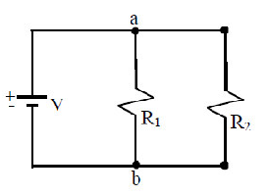

V= 5.02 V (applied voltage)
R₁= 11Ω V₁= 4.94 V (measured voltage)
R₂= 47Ω V₂= 4.94 V (measured voltage)
Calculate the total current I for this circuit. Find the percentage error between applied voltage and the voltages V₁ and V₂.

